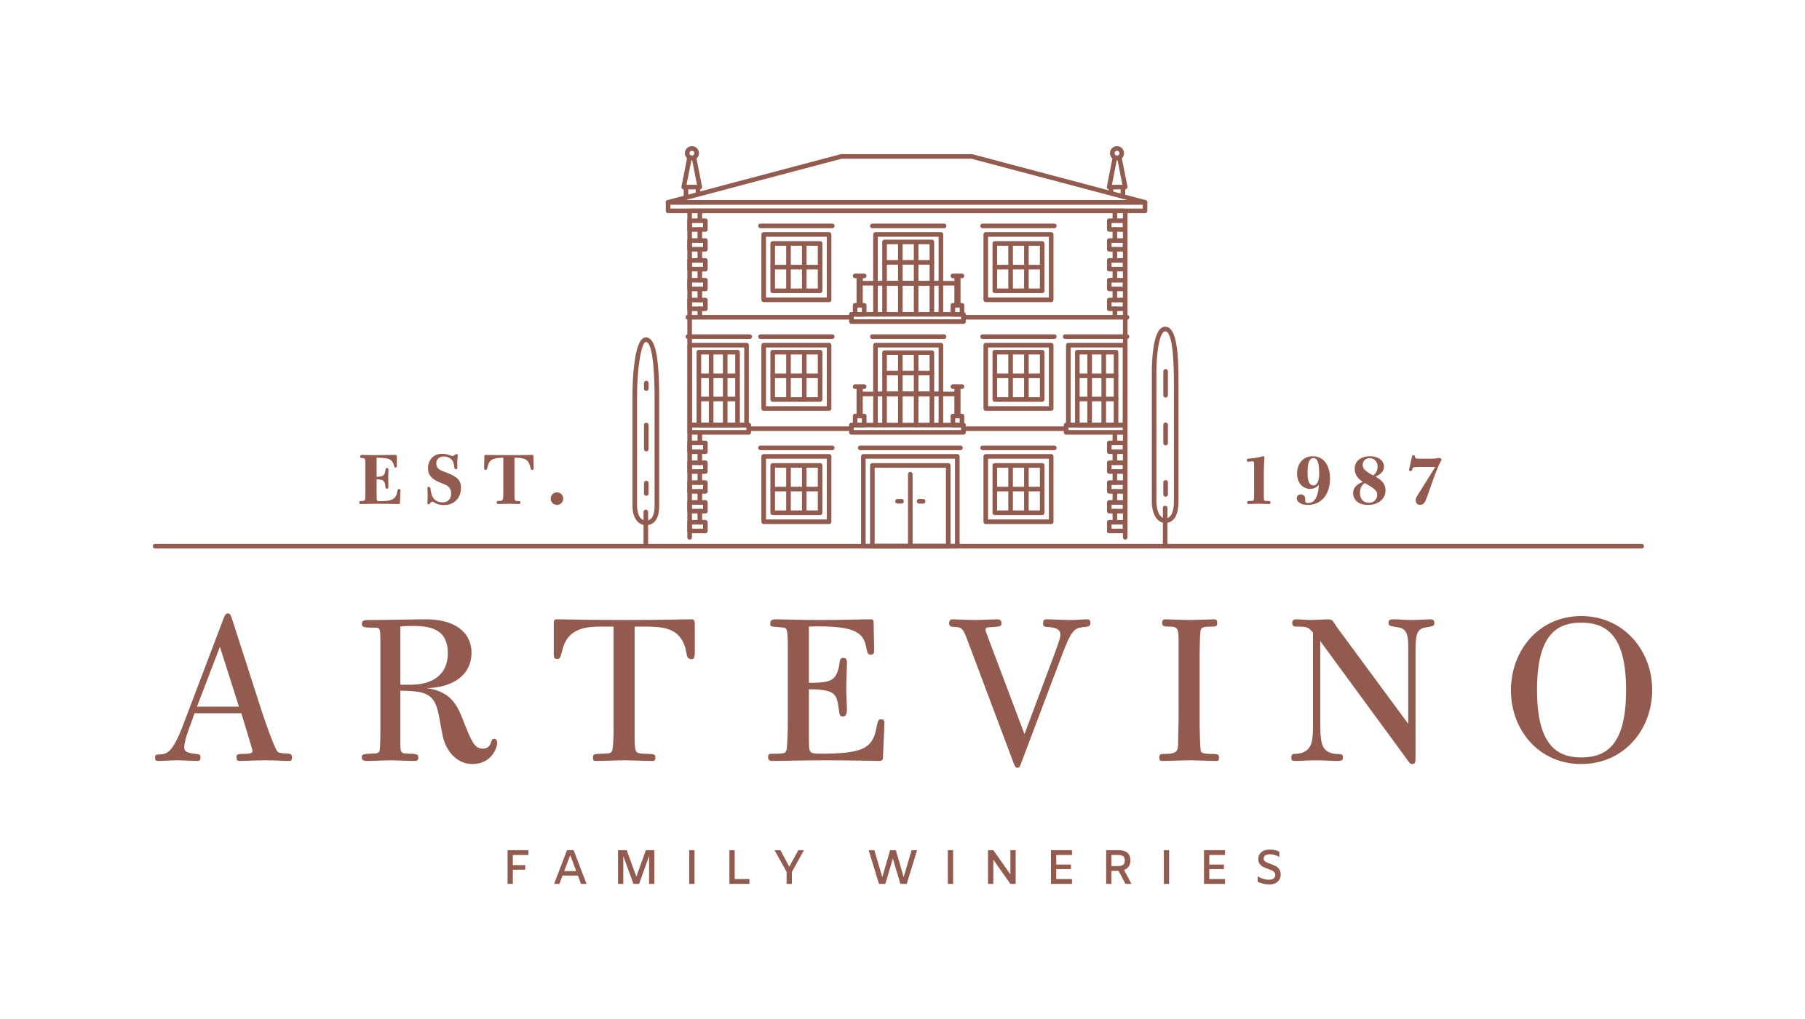

International Wine Challenge Award for
Artevino's Packaging

The ‘Happy New Twenties’ collection, featuring the company's four wineries, won the award for best design in the 2024 edition

Villabuena de Álava, December 2024. Artevino Family Wineries recieved the prestigious International Wine Challenge Award in the category of Best Packaging thanks to the ‘New Twenties’ project, a limited edition of wines including wines from Bodegas Izadi, Finca Villacreces, Vetus and Orben.

This project brings together the challenge of uniting strange varietal pairings, such as Graciano and Garnacha, in different designations of origin: Rioja, Ribera del Duero and Toro. This project that was born after the pandemic comes to proclaim a new happy 20s, a decade in which we can enjoy unusual things but that reconnect us with native varieties and the origin of each winery.
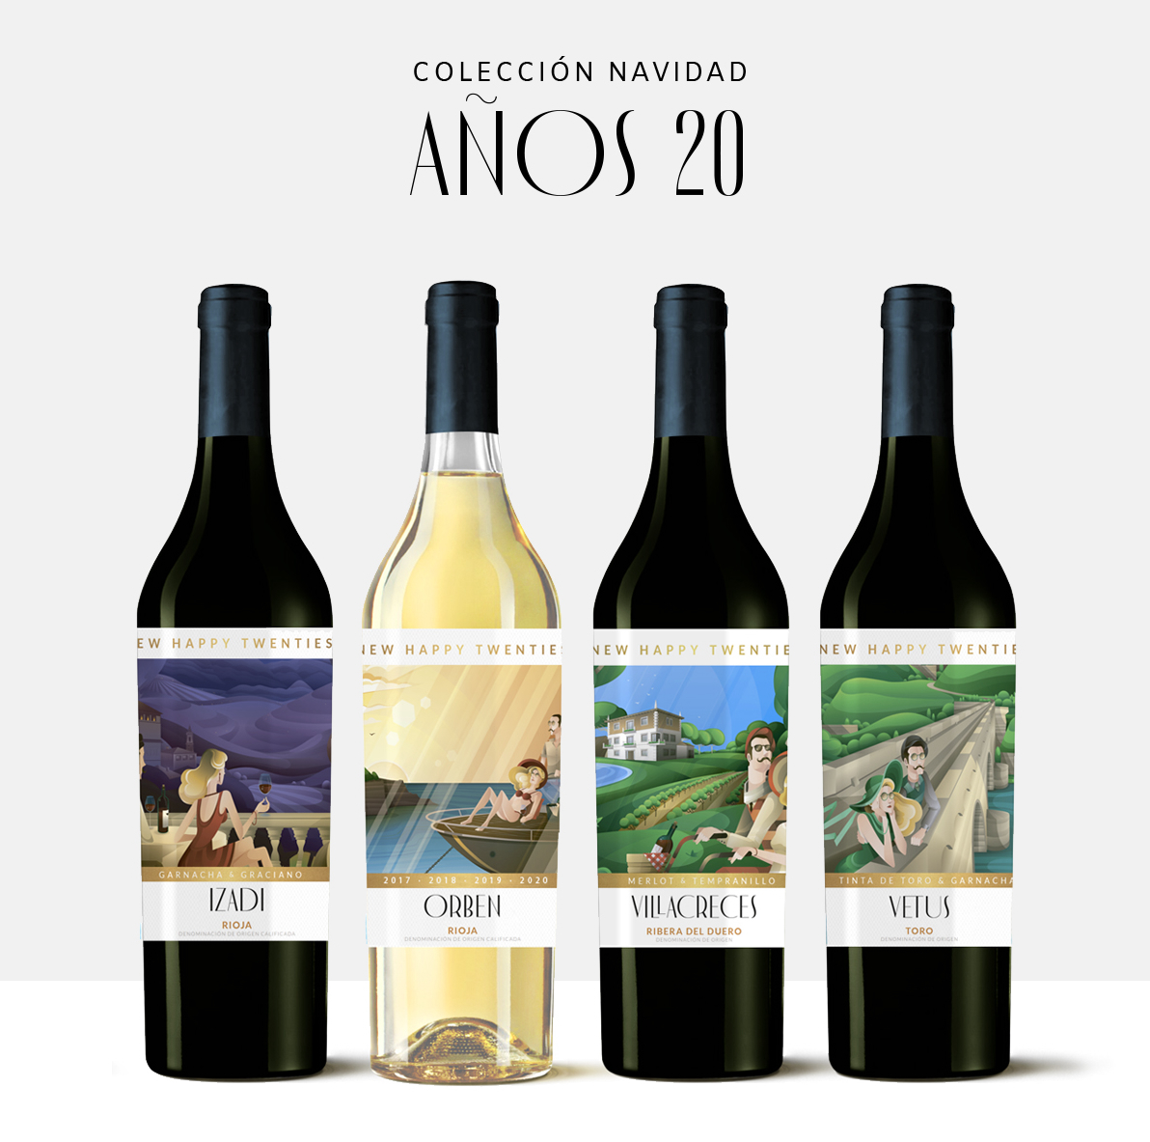
The design, based on illustrations by artist Aleix Gordo, talks about these strange couples experiencing wine in different situations. Only 2,000 units of this limited edition have been produced and can only be purchased on the wine company's website: www.artevinostore.es at a price of 100 euros.

The Artevino Family Wineries project adds a new award that was collected by its general manager, Lalo Antón, at the gala held on December 2 in Madrid, where the “New Happy Twenties” project won in a category in which La Rioja Alta and Conde del Pazo were also nominated.

Notes: Bodegas Izadi was founded in 1987 by Gonzalo Antón, a renowned hotelier from Vitoria. Currently, his son Lalo Antón runs this winery, parent company of Artevino Family Wineries (Finca Villacreces, Bodegas Vetus and Orben). Izadi is located in Villabuena de Álava, in the heart of the Rioja Alavesa. Restlessness, sensitivity, hospitality and respect mark the way of understanding the 187 hectares of old vineyards it manages. Its wines: Larrosa Rosé, Larrosa Blanca, Larrosa Negra, Izadi Selección and Izadi El Regalo VS. In 2023 it received the Best Of of wine tourism for its sustainable practices.
For more information:
Finca Villacreces- Iván Pérez – iperez@artevino.es - 616 510 586
10vcomunicación – Victoria Díez - victoria@10vcomunicacion.es - 629 682 802

